Course Title: AI-Assisted Coding
Batch – 06
Hall no. – 2303A51983
Question: Lab 1: Environment Setup – GitHub Copilot and VS Code Integration + Understanding AI-assisted Coding Workflow
Task 0 ● Install and configure GitHub Copilot in VS Code. Take screenshots of each step.
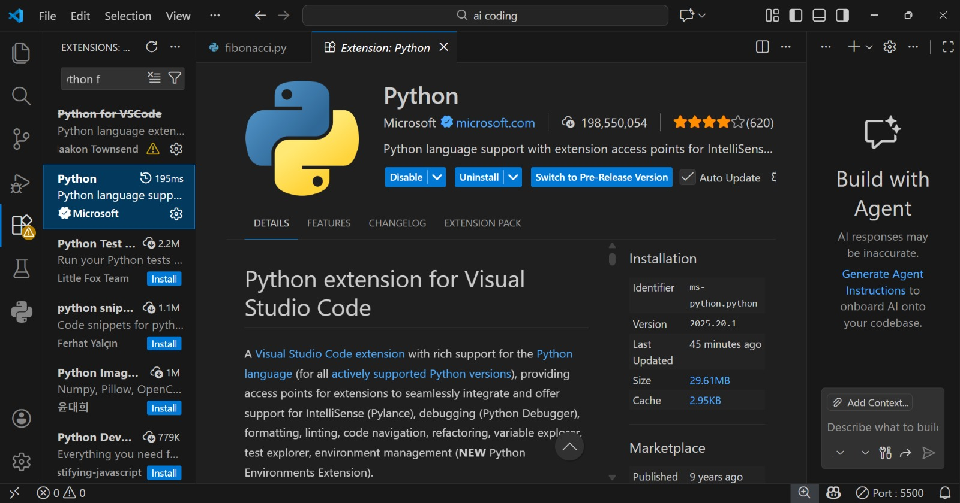
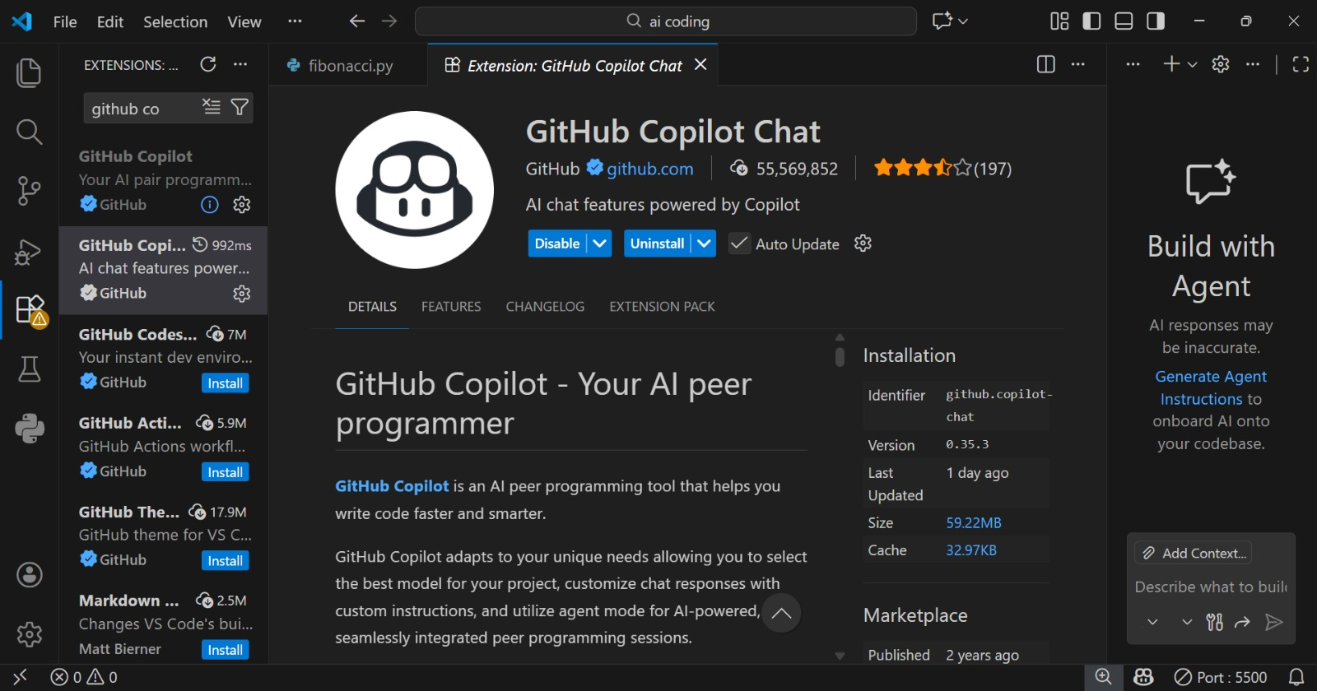
Explanation: I installed GitHub Copilot in VS Code using the Extensions option. Then I signed in with my GitHub account and allowed permissions. Copilot started giving code suggestions while typing, which made coding easier.
Task 1: AI-Generated Logic Without Modularisation (Fibonacci Sequence Without Functions)
Input :
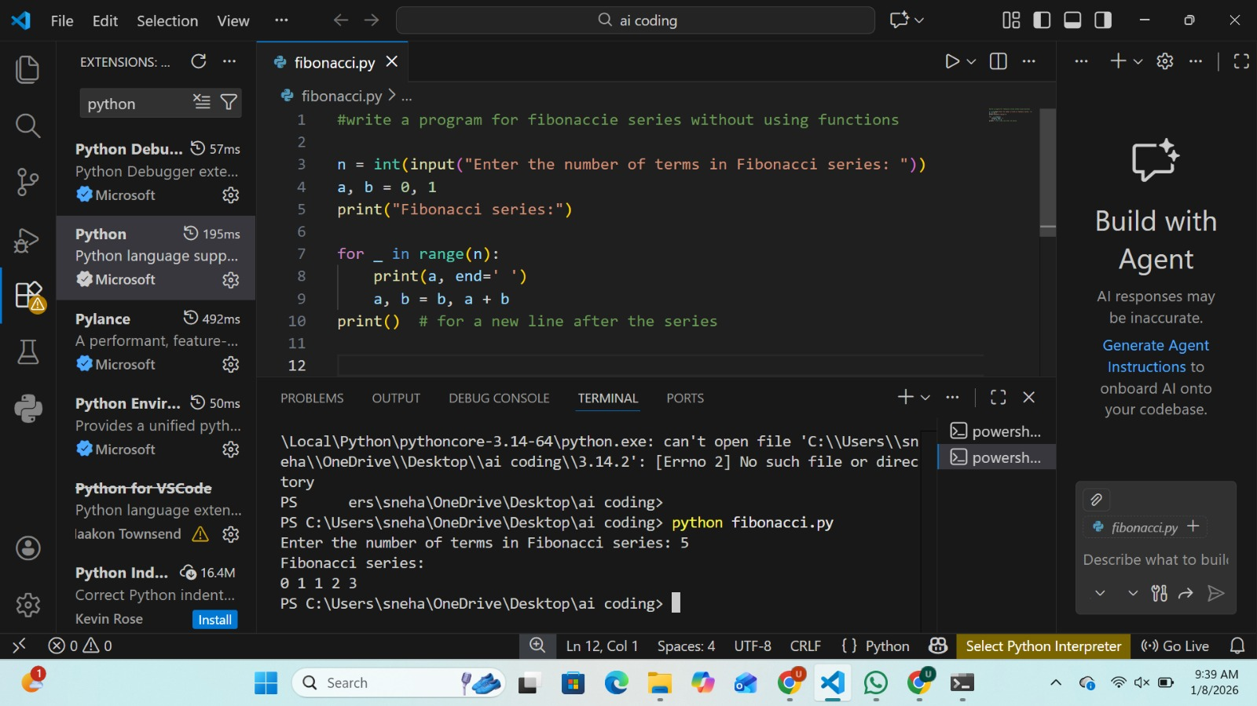
Output :
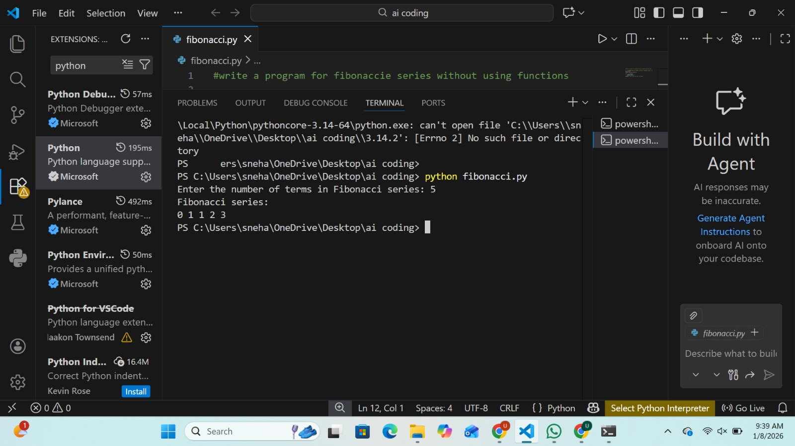
Explanation: The Fibonacci code is written in one place. No functions are used in this program. The code works, but it looks messy.
Task 2: AI-Code Optimisation & Cleanup (Improving Efficiency)
Input :
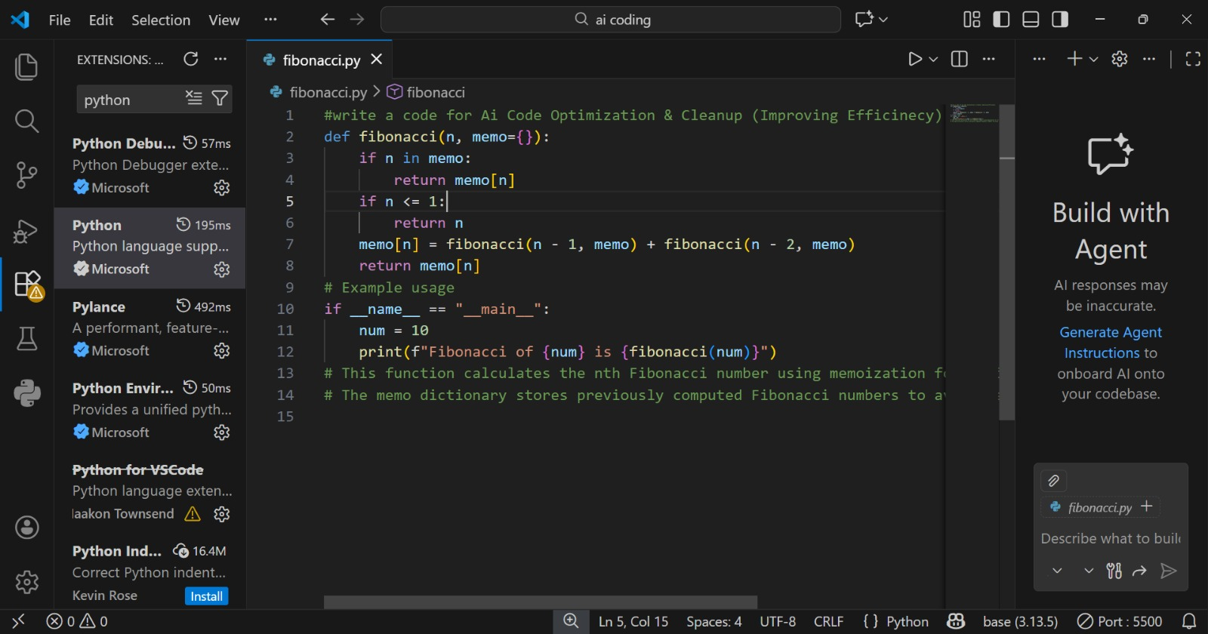
Output :
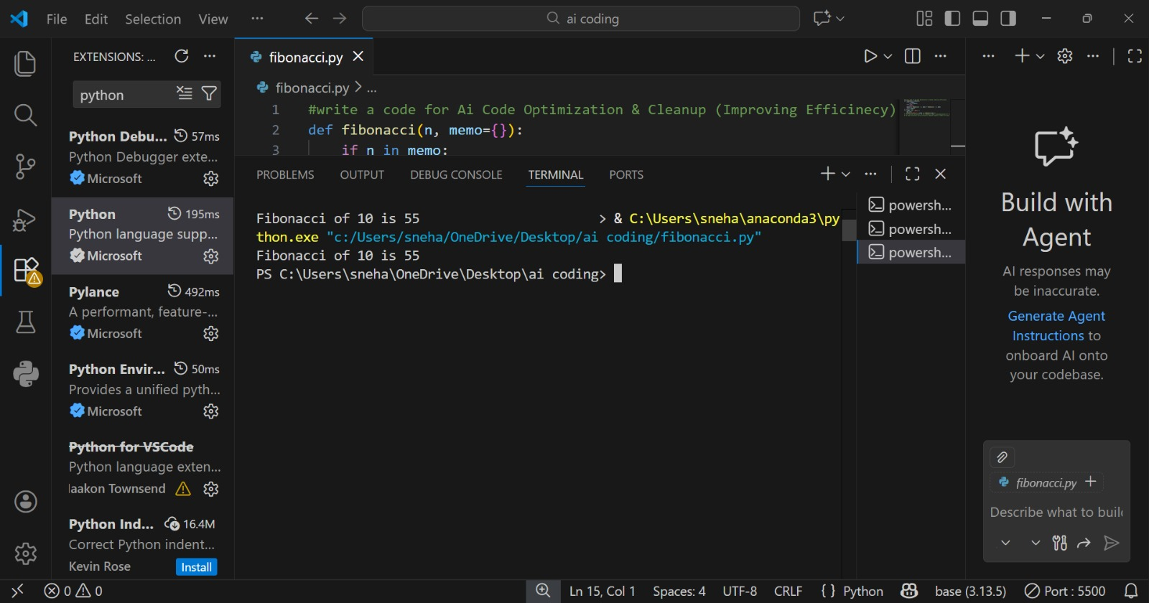
Explanation : AI removed extra and useless code.The program became short and clean.
Now it is easy to understand.
Task 3: Modular Design Using AI Assistance (Fibonacci Using Functions)
Input :
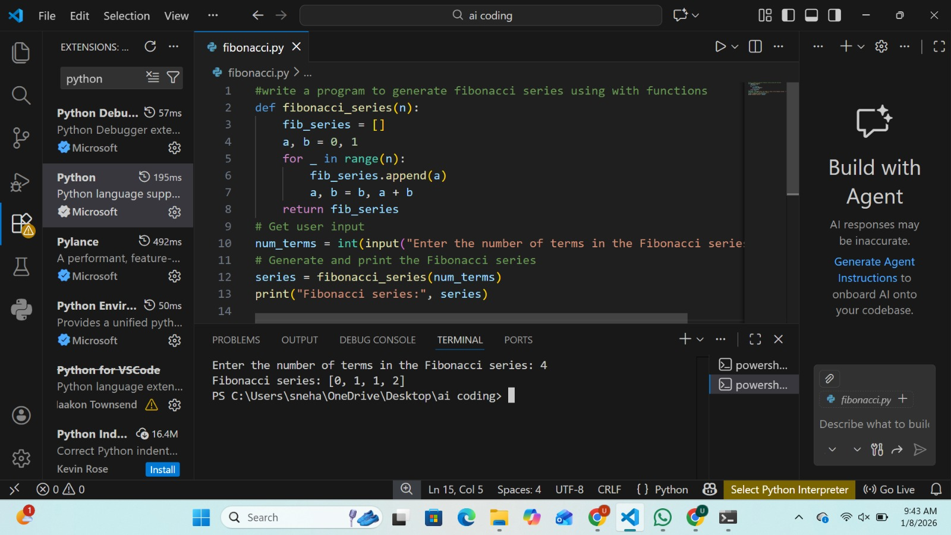
Output :
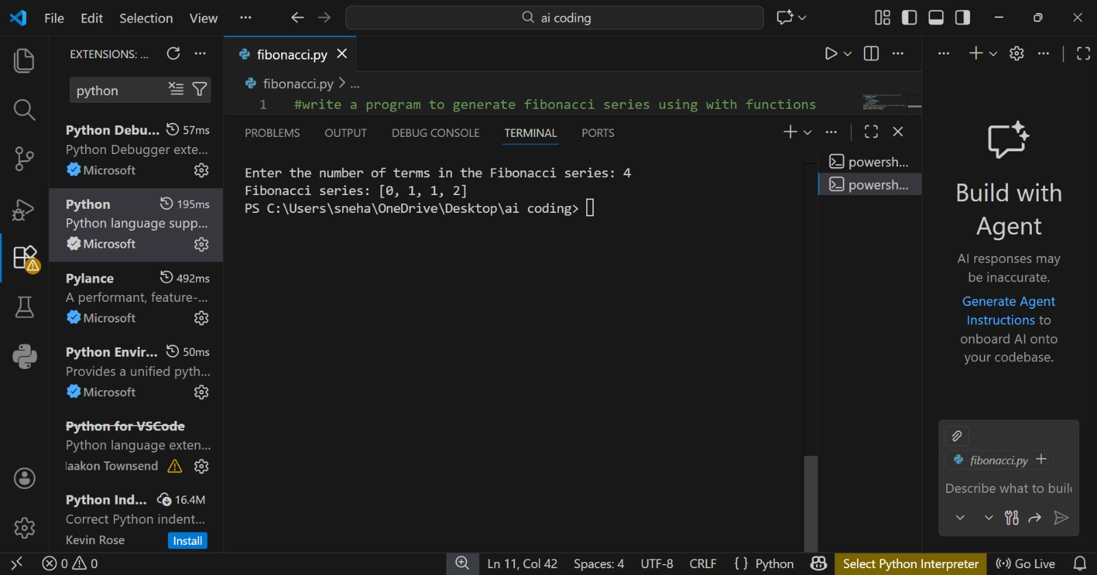
Explanation : The code is written using a function.This makes the program neat.
The function can be reused.

Task 4: Comparative Analysis – Procedural vs Modular Fibonacci Code
Input :
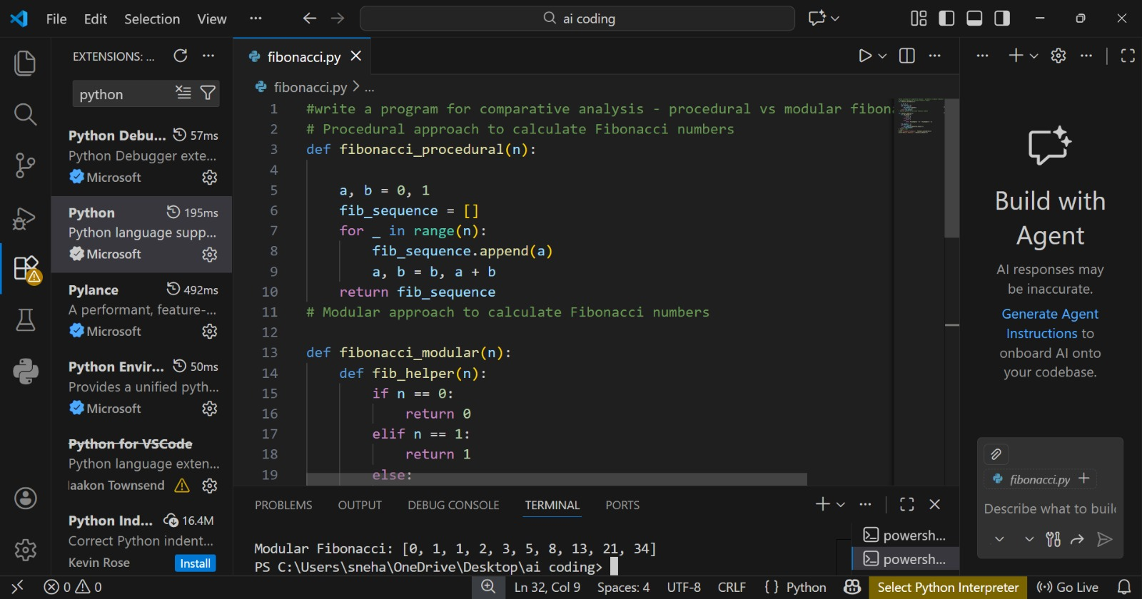
Output :

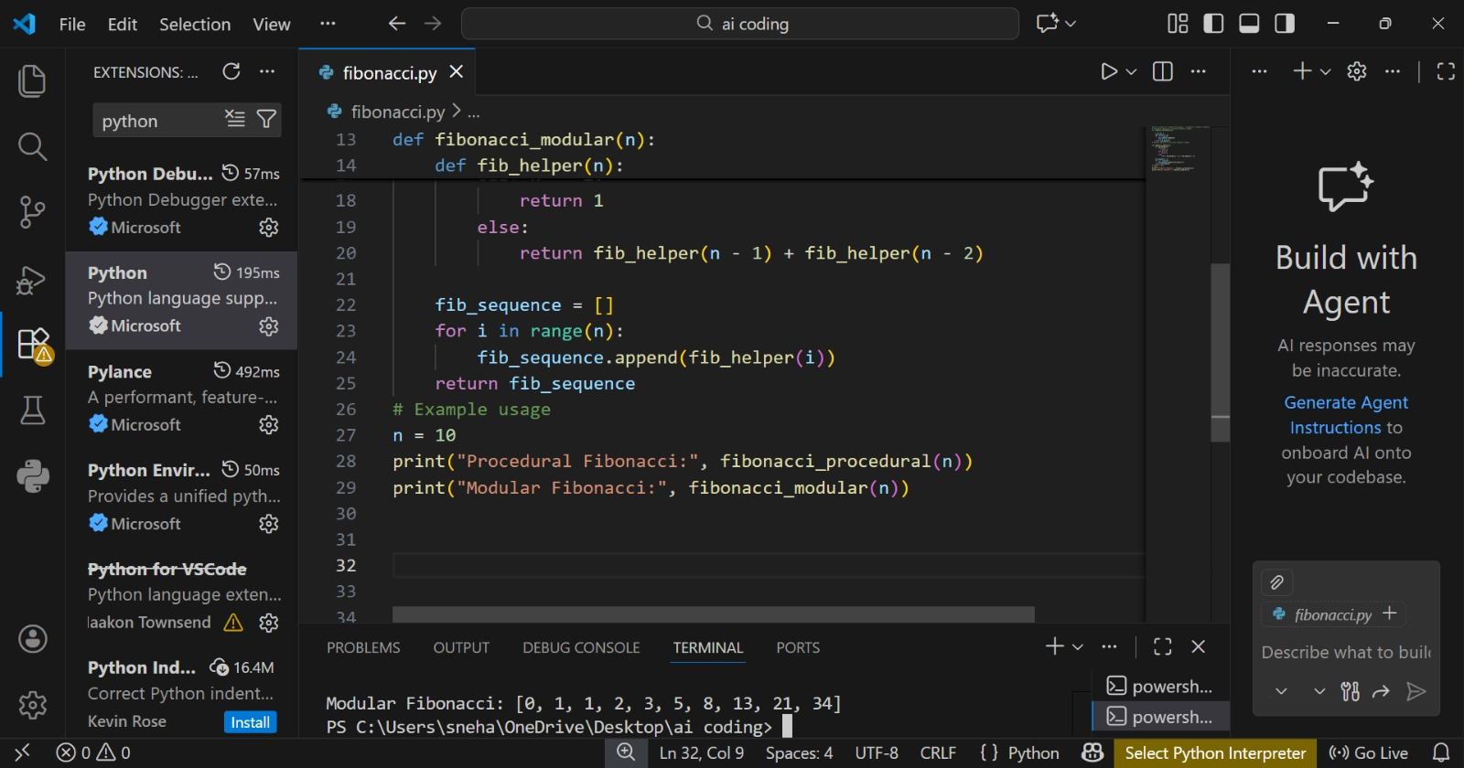
Explantion ; Procedural code is written in one block.Modular code uses functions.
Modular code is better and clearer.

Task 5: AI-Generated Iterative vs Recursive Fibonacci Approaches (Different Algorithmic Approaches for Fibonacci Series)
Input :
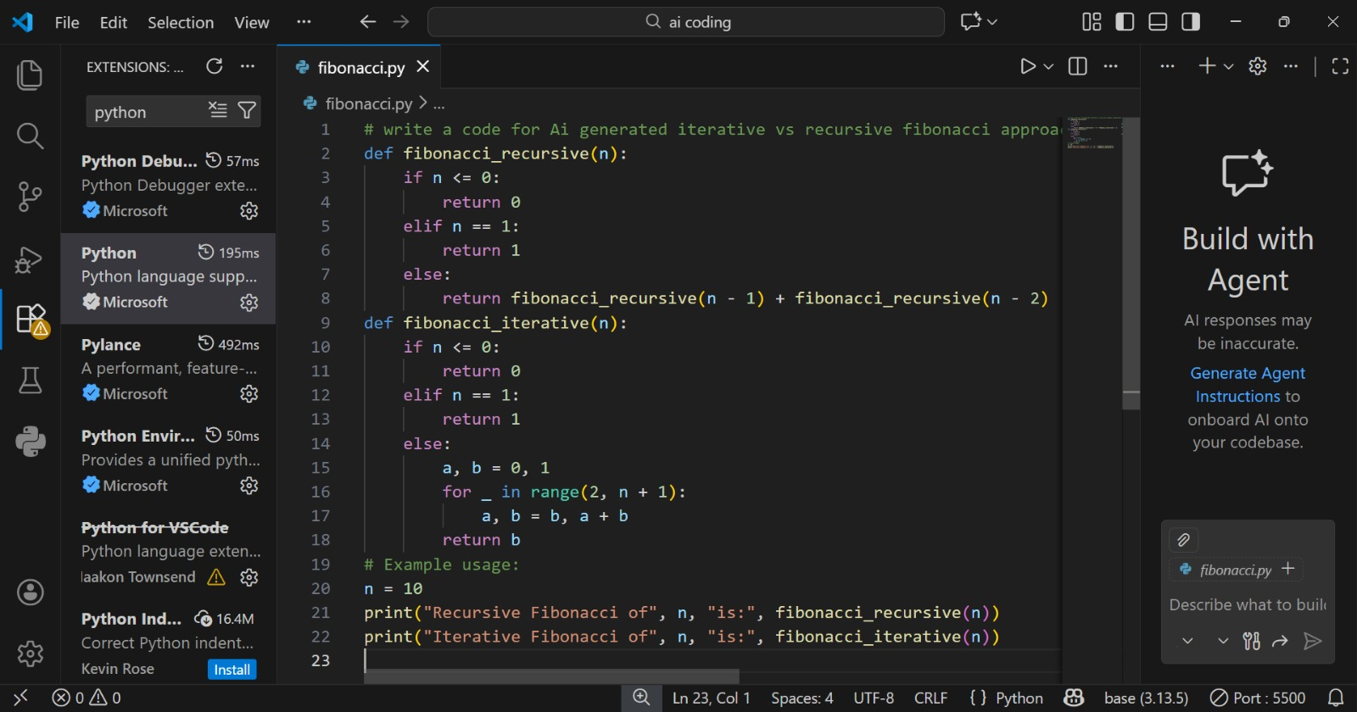

Output :
Explanation :
Iterative method uses a loop. Recursive method calls itself. The loop method is faster.

